- Le Marché du travail
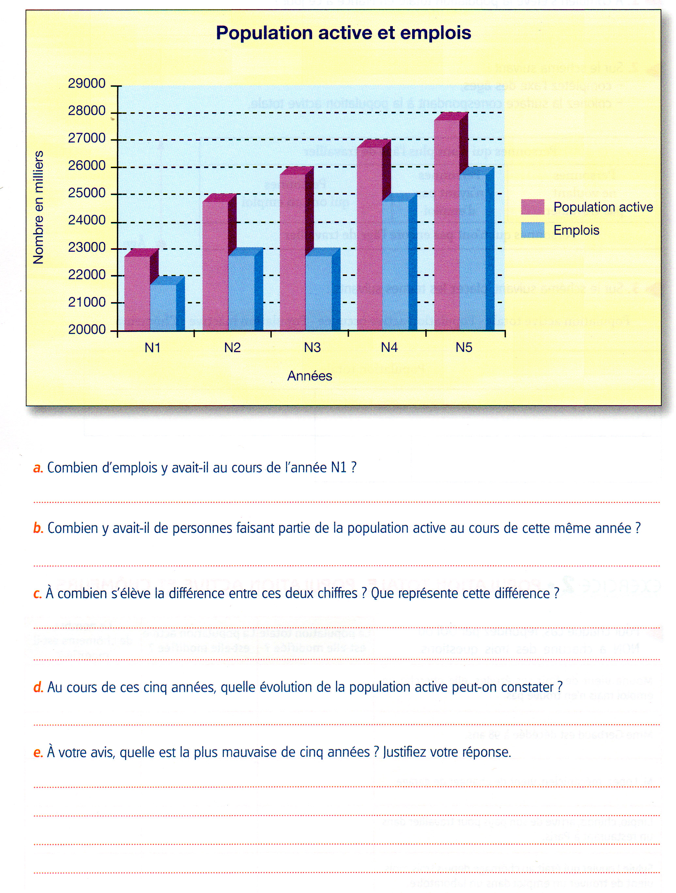
- La recherche d’un emploi
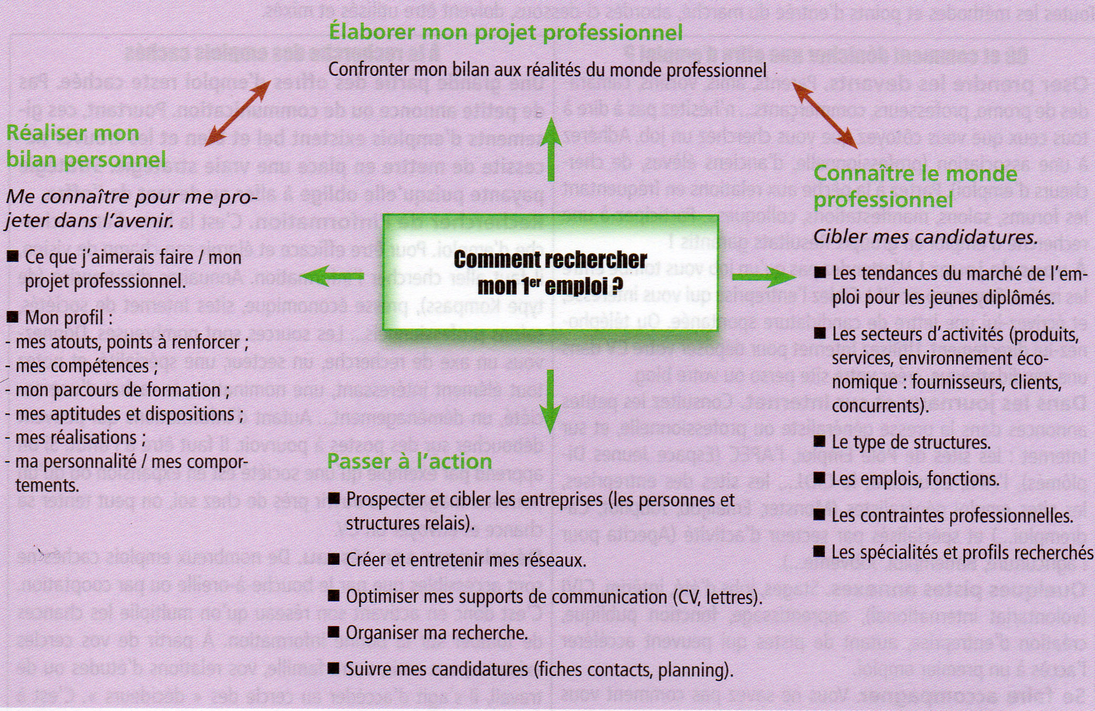
- Quelles sont les différentes étapes de la recherche d’emploi ?

………………………………………………………………………………………………………………………………………………………………………………………………………………………………………………………………………………………………………………………………………………………………………………………………………………………………………………………………………………………………………………………………………………………………………………………………………………………………………………………………………………………………………………………………………………………………………………………………………………………………………………………………………………………………………………………………………………………………………………………………………………………………………………………………………………………………………………………………………………………………………………………………………………………………………………………………………………………………………………………………………………………………………………………………………………………………………………………………………………………………………………………………………………………………………………………………………………………………………………………………………………………………………………………………………………………………………………………………………………………………………………………………………………………………………………………………………………………………………………
……………………………………………………………………………………………………………………………………………………………………………………………………………………………………………………………………………………………………………………………………………………………………………………………………………………………………………………
……………………………………………………………………………………………………………………………………………………………………………………………………………………………………………………………………………………………………………………………………………………………………………………………………………………………………………………

